Regulated water and sewerage services
2016−17 price adjustment

Report 3 of 2016, June 2016

The Independent Competition and Regulatory Commission is a Territory Authority established under the Independent Competition and Regulatory Commission Act 1997 (the ICRC Act). The Commission is constituted under the ICRC Act by one or more standing commissioners and any associated commissioners appointed for particular purposes. Commissioners are statutory appointments. Joe Dimasi is the current Senior Commissioner who constitutes the Commission and takes direct responsibility for delivery of the outcomes of the Commission.
The Commission has responsibilities for a broad range of regulatory and utility administrative matters. The Commission has responsibility under the ICRC Act for regulating and advising government about pricing and other matters for monopoly, near-monopoly and ministerially declared regulated industries, and providing advice on competitive neutrality complaints and government-regulated activities. The Commission also has responsibility for arbitrating infrastructure access disputes under the ICRC Act. In discharging its objectives and functions, the Commission provides independent robust analysis and advice.
The Commission’s objectives are set out in section 7 of the ICRC Act and section 3 of the Utilities Act 2000.
Correspondence or other inquiries may be directed to the Commission at the following addresses:
Independent Competition and Regulatory Commission
PO Box 161
Civic Square ACT 2608
Level 8
221 London Circuit
Canberra ACT 2601
The Commission may be contacted at the above addresses, by telephone on (02) 6205 0799, or by fax on (02) 6207 5887. The Commission’s website is at www.icrc.act.gov.au and our email address is icrc@act.gov.au.

Contents
1 Introduction 1
2 2016−17 price adjustment 3
2.1 Consumer price index adjustment 3
2.2 Pass-through adjustment 3
2.3 2016−17 maximum water prices 5
2.4 2016−17 maximum sewerage services prices 5
2.5 2016−17 maximum charges for miscellaneous services 5
3 Impact on customers 7
3.1 Water charges 7
3.2 Combined water and sewerage bills 8
Appendix 1 Maximum charge schedule 2016−17 11
Abbreviations and acronyms 17
References 19

List of tables
Table 2.1 Water prices, 2015–16 to 2016–17 ($, current prices) 5
Table 2.2 Sewerage services prices, 2015–16 to 2016–17 ($, current prices) 5
Table 3.1 Change in annual water charges for residential customers ($, current prices) 7
Table 3.2 Change in annual water charges for non-residential customers ($, current prices) 8
Table 3.3 Change in annual combined water and sewerage services bill for residential customers ($, current prices) 8
Table 3.4 Change in annual combined water and sewerage services bill for non-residential customers ($, current prices) 9

Introduction

The Substituted Price Direction for Regulated Water and Sewerage Services 1 July 2013 to 30 June 2018 (the price direction) requires the Independent Competition and Regulatory Commission (the Commission) to undertake a price adjustment process to determine the maximum prices Icon Water Ltd (Icon Water) can charge for its regulated water, sewerage and miscellaneous services in 2015–16, 2016−17 and 2017−18.
The price direction essentially requires that prices be adjusted for two things. The first is for inflation, which is the change in the consumer price index (CPI). The second is to incorporate the effect of any approved pass-through events on Icon Water’s costs in prices in the following year.
This report sets out the process undertaken by the Commission to determine maximum prices to apply in 2016−17.
The remainder of the report is structured as follows:
- Chapter 2 describes the price adjustment calculations and sets out the adjusted maximum prices to apply from 1 July 2016;
- Chapter 3 illustrates the impact of the price adjustments on water and sewerage services customer annual bills; and
- Appendix 1 presents the detailed schedule of maximum water, sewerage and miscellaneous service charges for 2016−17.

2016−17 price adjustment

Consumer price index adjustment
Clause 9.1 of the price direction requires the Commission to calculate the maximum prices for regulated water, sewerage and miscellaneous services for each regulatory year on the basis set out in clauses 6 and 7 and provide Icon Water with notice of the adjusted prices on or before 1 June each year. The Commission is also required to provide Icon water with details of the Commission’s calculations of the adjusted prices, including the values of the change in the CPI used in the calculations.
The CPI adjustment formula used by the Commission, as set out in clause 6.1 of the price direction, is presented below:
$${CPI}_{201617}=\frac{107.5+108.0+108.4+108.2}{105.9+106.4+106.6+106.8}-1=0.0150340615456894$$

Pass-through adjustment

General provisions
Clauses 8 and 9 of the price direction set out the process for incorporating the effect of any approved pass-through events on Icon Water’s costs in prices in the following year.
The price direction allows for seven pass-through events, three of which have been triggered for the 2016−17 price adjustment. These are events associated with the ACT Government’s Water Abstraction Charge (WAC) and utilities network facilities tax (UNFT) and Commonwealth subvention payment events.
Clause 9.2 of the price direction provides for Icon Water to submit a pass-through application to the Commission. Generally Icon Water is required to make the submission by 1 May with the Commission required to make a decision and advise Icon water by 30 May. In the event that Icon Water does not lodge a submission, Clause 9.5 of the price direction allows the Commission to initiate a pass-through amount.
The price direction also allows pass-through event amounts to be considered prospectively and retrospectively.

Approach to Commission-initiated pass-throughs
The prospective and retrospective feature of pass-through consideration has the potential to result in administratively complex and resource intensive adjustment processes. In an effort to minimise this complexity and cost, the Commission published a statement in May 2015 setting out its approach to Commission-initiated pass-through amounts. The Commission stated that it will only exercise its discretion under clause 9.5 of the price direction to initiate a price adjustment for a particular pass-through event when all of the costs associated with the event are known, unless it is reasonably clear that not initiating a prospective pass through will have a continuing and materially detrimental effect on Icon Water or its customers.

Pass-throughs for 2016−17 prices

Icon Water submission
Icon Water provided a pass-through submission to the Commission on 29 April 2016 for consideration in 2016−17 prices. Consistent with the Commission's May 2015 approach, the submission relates to amounts associated with WAC, UNFT and subvention payments for the 2014−15 financial year, the most recent year for which actual data is available. Icon Water’s submission requested that negative pass-through amounts in 2016−17 dollars of $1,892,156 and $356,674 for water and sewerage, respectively, be taken into consideration.

Commission’s decision
When setting prices in advance of a regulatory period, a forecast of the amount of the WAC and UNFT to be recovered from customers by Icon Water and paid to the ACT Government in any particular year is required. In the case of the Commonwealth subvention payment, the forecast amount is subtracted from Icon Water’s revenue requirement and is therefore excluded from customer charges. Any difference between the forecast and actual amounts is then subject to an annual pass-through adjustment, which can be positive or negative. Positive pass-throughs raise prices, while negative pass-throughs bring prices down.
The negative pass-through amounts of about $1.9 million for water and $357,000 for sewerage in the 2016−17 price adjustment are primarily associated with a divergence between the WAC and UNFT forecast amounts and the actual amounts collected and paid in 2014−15.
For example, when setting water prices for 2014−15, the Industry Panel used what turned out to be an overambitious forecast of water sales for that year. Since the WAC forecast amount is dependent on the level of forecast water sales, the WAC forecast also turned out to be too high. This means that Icon Water collected more WAC revenue from its customers in 2014−15 than it needed to pay the ACT Government. This discrepancy has been corrected by the negative pass-through in 2016−17 prices.
In accordance with clause 9.2 of the price direction, the Commission’s decision is that the pass-through events specified in the submission occurred and fall within the scope of clause 8 and the Commission approves the negative pass-through amounts proposed by Icon Water.
In calculating the pass-through price adjustment, in conformity with the post-tax model used to calculate the price path in the price direction, account has been taken of the time value of money (at the weighted average cost of capital), and its effect on the return to shareholders (tax equivalent payments and imputation credits).
The pass-through price adjustment to account for the pass-through amounts, which is applied in addition to the CPI adjustment, is calculated as:
- negative 0.01145977265520120 for water; and
- negative 0.00312920360936482 for sewerage.

2016−17 maximum water prices
The CPI and pass-through adjustments have been applied to the fixed charge and two volumetric charges, as per the formula below, with prices rounded to the nearest cent:
$$P_{201617}=P_{201516}×\left(1+{CPI}_{201617}\right)×\left(1+{PT adj water}_{201617}\right)$$
Calculated water prices for 2016−17 are shown in Table 2.1. The fixed charge and volumetric charges have increased by less than one half of a per cent, as the negative pass-through adjustment has almost completely offset the positive CPI adjustment.
Table 2.1 Water prices, 2015–16 to 2016–17 ($, current prices)
 | 2015–16 | 2016–17 | Change (%)
Fixed ($/year) | 101.14 | 101.48 | 0.3
Tier 1 (0–200 kL/a) ($/kL) | 2.60 | 2.61 | 0.4
Tier 2 (200 kL/a+) ($/kL) | 5.22 | 5.24 | 0.4

2016−17 maximum sewerage services prices
Maximum sewerage services prices for 2016−17 have been calculated using the following formula, with prices rounded to the nearest cent:
$$P_{201617}=P_{201516}×\left(1+{CPI}_{201617}\right)× \left(1+{PT adj sewerage}_{201617}\right)$$
Calculated sewerage services prices for 2016−17 are shown in Table 2.2. Prices have increased by 1.2 per cent from 2015−16, slightly less than the change in the CPI due to the negative pass-through adjustment.
Table 2.2 Sewerage services prices, 2015–16 to 2016–17 ($, current prices)
 | 2015–16 | 2016–17 | Change (%)
Supply charge ($/year) | 523.18 | 529.38 | 1.2
Fixture charge non-residential customers ($/year)a | 511.66 | 517.73 | 1.2
a For every additional flushing fixture greater than two.

2016−17 maximum charges for miscellaneous services
Maximum charges for miscellaneous services for 2016−17 have been calculated using the following formula, with charges rounded to the nearest dollar for the GST-inclusive price:
$$P_{201617}=P_{201516}×\left(1+{CPI}_{201617}\right)$$
The full list of calculated maximum miscellaneous services charges for 2016−17 is provided in Appendix 1.

Impact on customers

This chapter outlines the financial impact on ACT consumers of the Commission’s final decision on maximum water and sewerage service prices. It does this by illustrating the impact of the change in water and sewerage service prices in 2016−17 on annual water charges and combined water and sewerage services bills.

Water charges
Table 3.1 shows the change in annual water charges from 2015–16 to 2016–17 for residential customers at different consumption levels.
Table 3.1 Change in annual water charges for residential customers ($, current prices)
Annual water consumption (kL) | Annual 2015–16 water charge ($) | Annual 2016–17 water charge($) | Change in water charge (%) | Change in water charge ($)
0 | 101 | 101 | 0.3% | 0
50 | 231 | 232 | 0.4% | 1
100 | 361 | 362 | 0.4% | 1
150 | 491 | 493 | 0.4% | 2
200 | 643 | 645 | 0.4% | 2
250 | 882 | 885 | 0.4% | 3
300 | 1,143 | 1,147 | 0.4% | 4
350 | 1,404 | 1,409 | 0.4% | 5
400 | 1,665 | 1,671 | 0.4% | 6
500 | 2,187 | 2,195 | 0.4% | 8
750 | 3,492 | 3,505 | 0.4% | 13
Table 3.1 shows that for a typical customer consuming 200 kilolitres (kL) per year, their annual water charge will increase by about 0.4 per cent, or $2. Table 3.2 shows a percentage increase of about 0.4 per cent for non-residential customer annual water charges. Increases range from a low of $18 to a high of $198 per year.

Table 3.2 Change in annual water charges for non-residential customers ($, current prices)
Annual water consumption (kL) | Annual 2015–16 water charge ($) | Annual 2016–17 water charge ($) | Change in water charge (%) | Change in water charge ($)
1,000 | 4,797 | 4,815 | 0.4% | 18
2,000 | 10,017 | 10,055 | 0.4% | 38
5,000 | 25,677 | 25,775 | 0.4% | 98
10,000 | 51,777 | 51,975 | 0.4% | 198

Combined water and sewerage bills
Table 3.3 shows the change from 2015–16 to 2016–17 in the combined water and sewerage services bill for residential customers. A typical customer consuming 200 kL of water per year will see an increase in their combined bill of 0.7 per cent, or $9.
Table 3.3 Change in annual combined water and sewerage services bill for residential customers ($, current prices)
Annual water consumption (kL) | Annual 2015–16 combined bill ($) | Annual 2016–17 combined bill ($) | Change in combined bill (%) | Change in combined bill ($)
0 | 624 | 631 | 1.0% | 7
50 | 754 | 761 | 0.9% | 7
100 | 884 | 892 | 0.9% | 8
150 | 1,014 | 1,022 | 0.8% | 8
200 | 1,166 | 1,175 | 0.7% | 9
250 | 1,405 | 1,415 | 0.7% | 10
300 | 1,666 | 1,677 | 0.6% | 11
350 | 1,927 | 1,939 | 0.6% | 12
400 | 2,188 | 2,201 | 0.6% | 13
500 | 2,710 | 2,725 | 0.5% | 15
750 | 4,015 | 4,035 | 0.5% | 20
Table 3.4 shows the change from 2015–16 to 2016–17 in the combined annual water and sewerage services bill for non-residential customers. Bill increases range from a low of $85 to a high of $812 per year.
Table 3.4 Change in annual combined water and sewerage services bill for non-residential customers ($, current prices)
Annual water consumption (kL) | Number of billable fixtures (#) | Annual 2015–16 combined bill ($) | Annual 2016–17 combined bill ($) | Change in combined bill (%) | Change in combined bill ($)
1,000 | 10 | 10,437 | 10,522 | 1% | 85
 | 50 | 30,903 | 31,231 | 1% | 328
 | 100 | 56,486 | 57,118 | 1% | 632
2,000 | 10 | 15,657 | 15,762 | 1% | 105
 | 50 | 36,123 | 36,471 | 1% | 348
 | 100 | 61,706 | 62,358 | 1% | 652
5,000 | 10 | 31,317 | 31,482 | 1% | 165
 | 50 | 51,783 | 52,191 | 1% | 408
 | 100 | 77,366 | 78,078 | 1% | 712
10,000 | 10 | 57,417 | 57,682 | 0% | 265
 | 50 | 77,883 | 78,391 | 1% | 508
 | 100 | 103,466 | 104,278 | 1% | 812

- Maximum charge schedule 2016−17

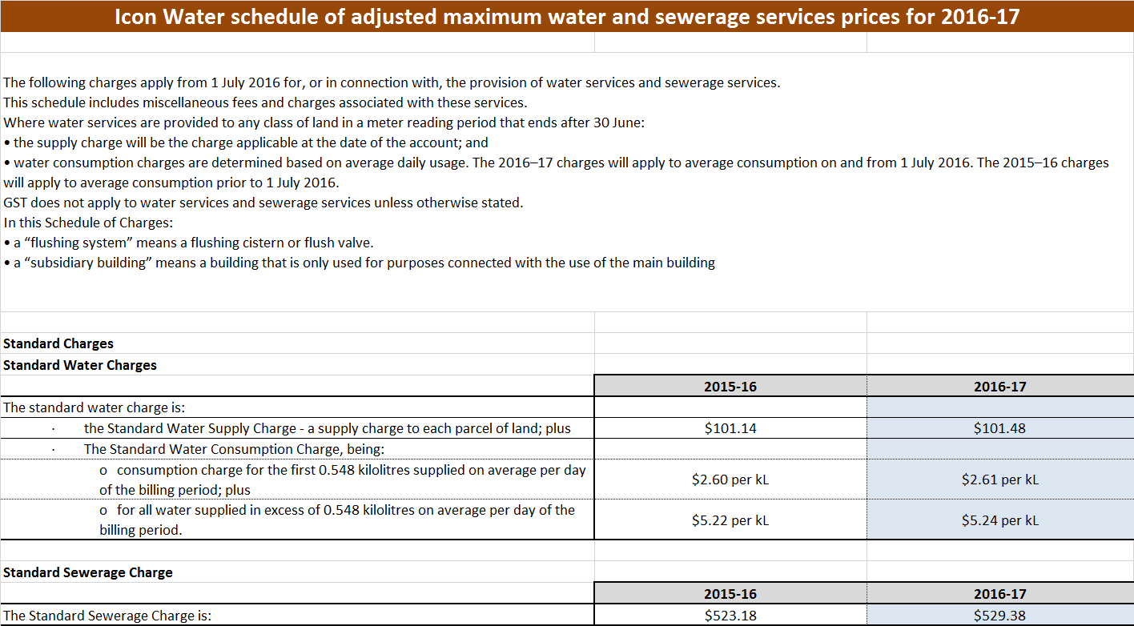

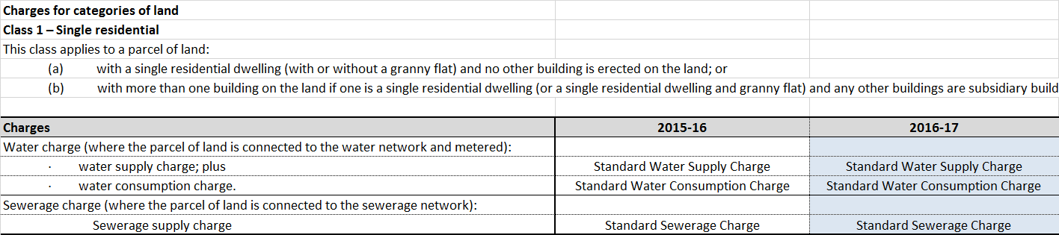

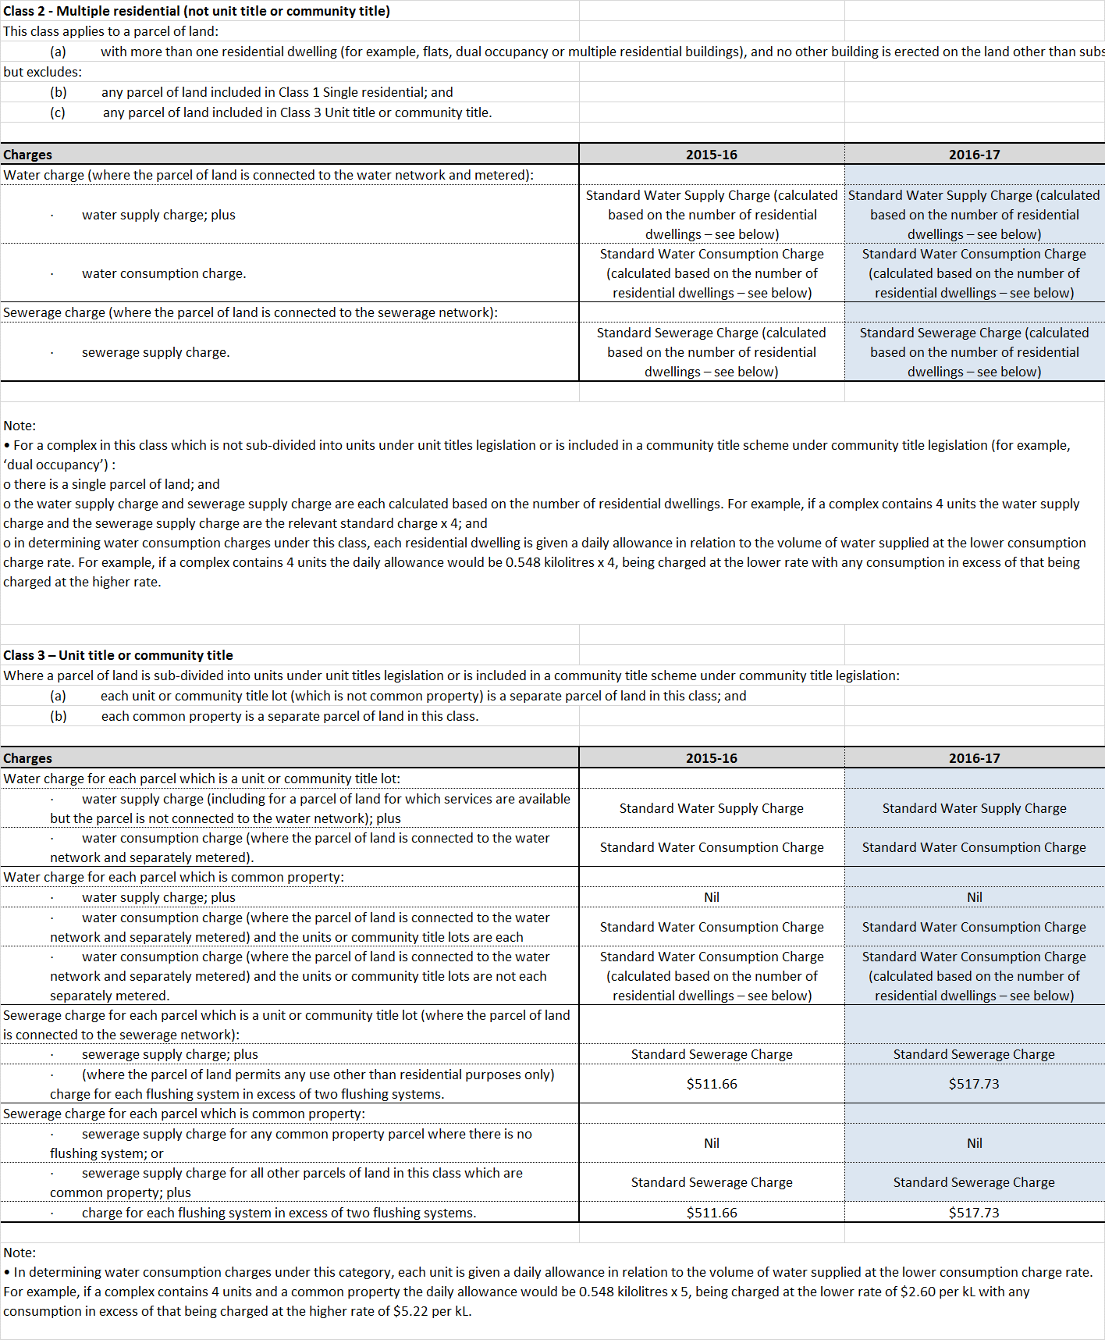

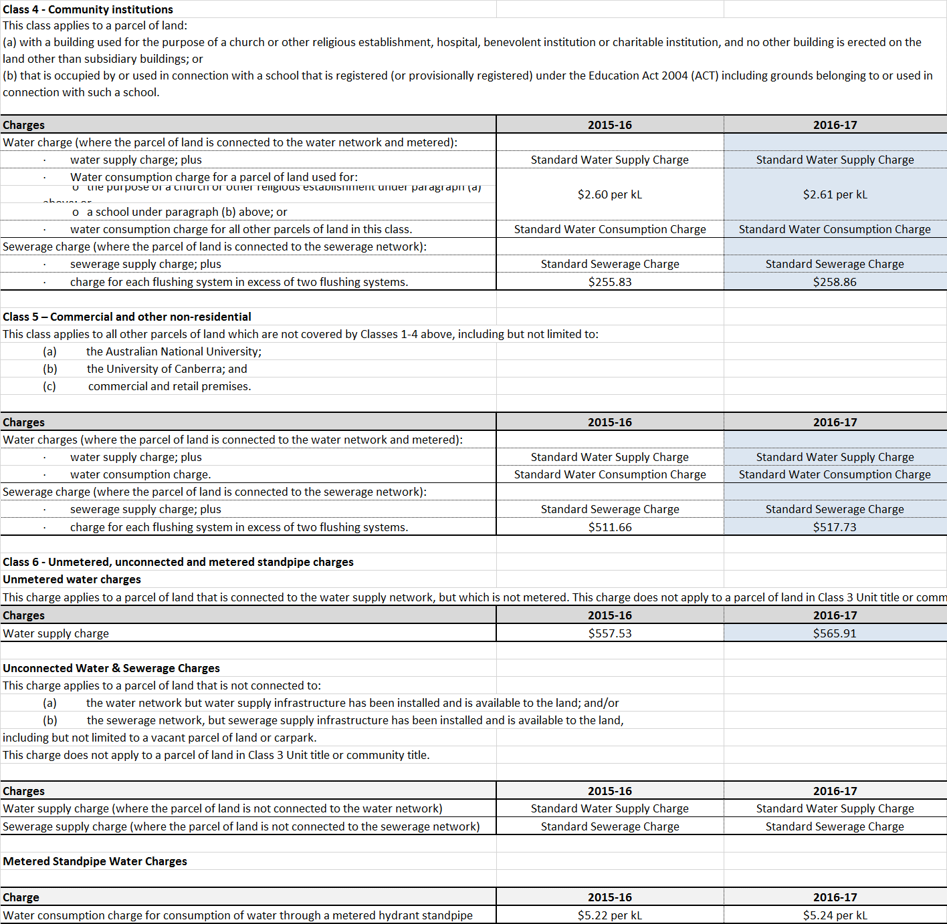

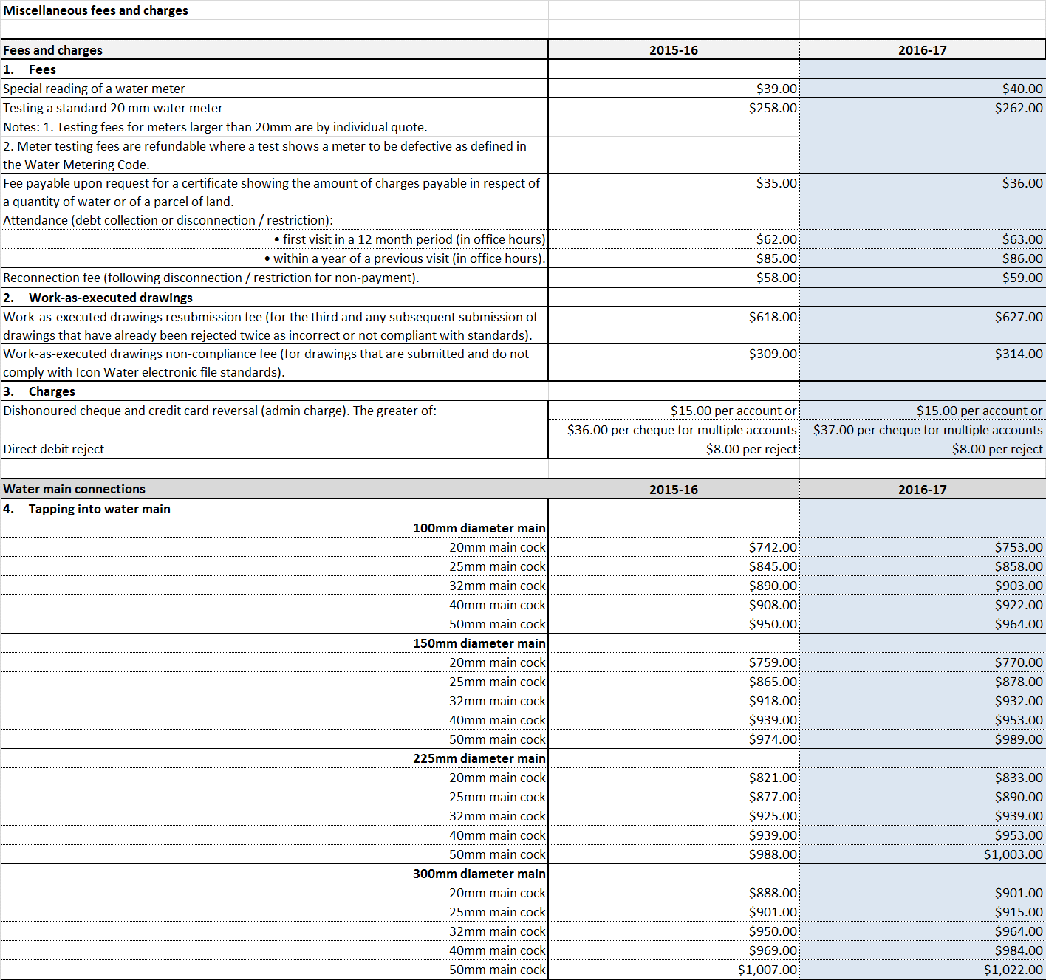

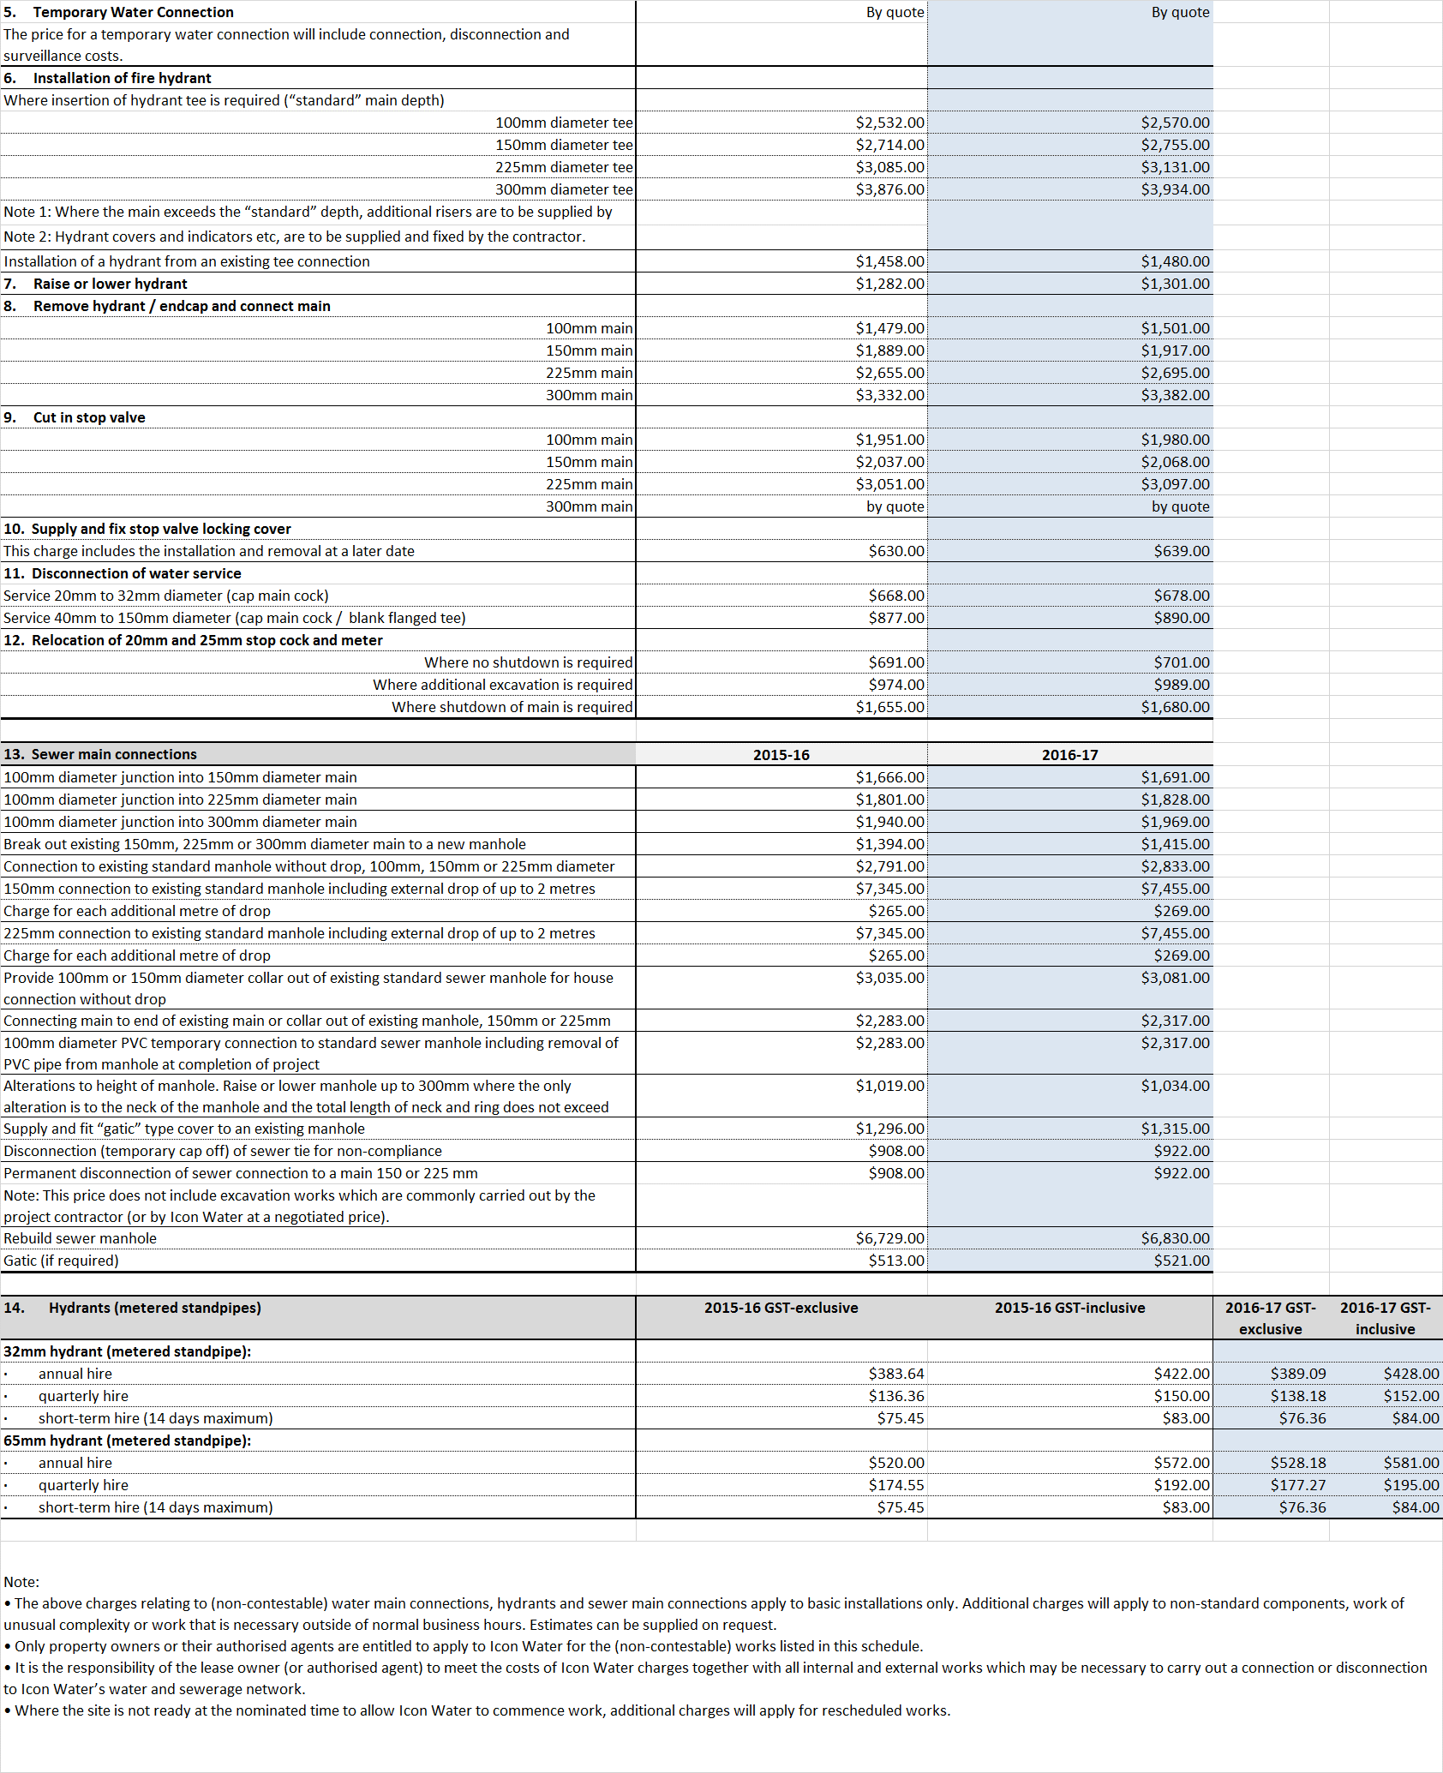

Abbreviations and acronyms

Commission | Independent Competition and Regulatory Commission
CPI | Consumer price index
ICRC | Independent Competition and Regulatory Commission
ICRC Act | Independent Competition and Regulatory Commission Act 1997 (ACT)
kL | kilolitre
price direction | Substituted Price Direction for Regulated Water and Sewerage Services 1 July 2013 to 30 June 2018
UNFT | Utilities Network Facilities Tax
WAC | Water abstraction charge

References
ICRC (2015) Statement on Commission-initiated pass-through events. Independent Competition and Regulatory Commission, Canberra. May 2015.
Industry Panel (2015) Substituted Price Direction: Regulated water and sewerage services 1 July 2013 to 30 June 2018 2013, Industry Panel, Canberra. April 2015.

Industry Panel (2015). Available at: http://www.icrc.act.gov.au/water-and-sewerage/inquiries-and-investigations/.
The CPI adjustment for 2016−17 prices is not a forecast of inflation in that year but rather is based on historical changes in the CPI up to March 2016, using what is known as the ‘four quarter on four quarter’ approach.
ICRC (2015). Available at: http://www.icrc.act.gov.au/water-and-sewerage/inquiries-and-investigations/.
Continuing in this regard means that the effect of the pass-through will continue in future years in the same direction, either adding costs (requiring a positive pass-through and price adjustment) or reducing costs (requiring a negative pass-through and price adjustment).
The Commission will apply a materiality threshold of $2 million per year.
The calculations include the application of daily pricing consistent with historical water use in each quarter. This means that 200 kL per year customers pay for a small amount of water at the tier 2 price in some quarters.

