Regulated water and sewerage services

2017−18 price adjustment

Report 5 of 2017, June 2017

The Independent Competition and Regulatory Commission is a Territory Authority established under the Independent Competition and Regulatory Commission Act 1997 (the ICRC Act). The Commission is constituted under the ICRC Act by one or more standing commissioners and any associated commissioners appointed for particular purposes. Commissioners are statutory appointments. Joe Dimasi is the current Senior Commissioner who constitutes the Commission and takes direct responsibility for delivery of the outcomes of the Commission.

The Commission has responsibilities for a broad range of regulatory and utility administrative matters. The Commission has responsibility under the ICRC Act for regulating and advising government about pricing and other matters for monopoly, near-monopoly and ministerially declared regulated industries, and providing advice on competitive neutrality complaints and government-regulated activities. The Commission also has responsibility for arbitrating infrastructure access disputes under the ICRC Act. In discharging its objectives and functions, the Commission provides independent robust analysis and advice.

The Commission’s objectives are set out in section 7 and 19L of the ICRC Act and section 3 of the *Utilities Act 2000*.

Correspondence or other inquiries may be directed to the Commission at the following addresses:

Independent Competition and Regulatory Commission  
PO Box 161  
Civic Square ACT 2608

Level 8  
221 London Circuit  
Canberra ACT 2601

The Commission may be contacted at the above addresses, by telephone on (02) 6205 0799, or by fax on (02) 6207 5887. The Commission’s website is at [www.icrc.act.gov.au](http://www.icrc.act.gov.au) and our email address is [icrc@act.gov.au](mailto:icrc@act.gov.au).

**Contents**

1 Introduction 1

2 2017−18 price adjustment 3

2.1 Consumer price index adjustment 3

2.2 Pass-through adjustment 3

2.3 2017−18 maximum water prices 5

2.4 2017−18 maximum sewerage services prices 6

2.5 2017−18 maximum charges for miscellaneous services 6

2.6 Icon Water’s proposal for a new miscellaneous charge 6

3 Impact on customers 7

3.1 Water charges 7

3.2 Combined water and sewerage bills 8

Appendix 1 Water, sewerage and miscellaneous service charges 2017−18 11

Abbreviations and acronyms 19

References 21

**List of tables**

Table 2.1 Pass-through amounts, 2015–16 ($, 2015–16) 4

Table 2.2 Water prices, 2016–17 to 2017–18 ($, current prices, percentages to two decimal places) 6

Table 2.3 Sewerage services prices, 2016–17 to 2017–18 ($, current prices, percentages to two decimal places) 6

Table 3.1 Change in annual water charges for residential customers from 2016–17 to 2017–18 ($, current prices, percentages to two decimal places) 7

Table 3.2 Change in annual water charges for non-residential customers from 2016–17 to 2017–18 ($, current prices, percentages to two decimal places) 8

Table 3.3 Change in annual combined water and sewerage services bill for residential customers from 2016–17 to 2017–18 ($, current prices, percentages to two decimal places) 8

Table 3.4 Change in annual combined water and sewerage services bill for non-residential customers from 2016–17 to 2017–18 ($, current prices, percentages to two decimal places) 9

# Introduction

The *Substituted Price Direction for Regulated Water and Sewerage Services 1 July 2013 to 30 June 2018* (the price direction) requires the Independent Competition and Regulatory Commission (the Commission) to undertake a price adjustment process to determine the maximum prices that Icon Water Limited (Icon Water) can charge for its regulated water, sewerage and miscellaneous services in 2015–16, 2016−17 and 2017−18.[1]

This price direction adjusts water, sewerage and miscellaneous prices to account for two cost variations. The first is for inflation, which is the change in the consumer price index (CPI). The second is to incorporate approved pass-through events into Icon Water’s costs in the following year, and adjust prices accordingly.

On 1 May 2017, Icon Water provided the Commission with a submission that estimated the 2017−18 CPI adjustment and applied for a pass-through adjustment to be incorporated in Icon Water’s regulated charges from 1 July 2017. In this submission, Icon Water further proposed to split the current single schedule of charges into three sub-schedules to differentiate the charges that are covered by the Standard Customer Contract (SCC) and those that are not covered.[2] The submission also included an application for a new miscellaneous service to allow for the introduction of a precinct charge under the proposed water and sewerage capital contribution code.

This report sets out the Commission’s final decision on the maximum prices for regulated water, sewerage and miscellaneous services to apply in 2017−18.

The proposed changes to the schedule of charges do not have any implications for the final outcome or the maximum prices determined by the Commission. The Commission believes that Icon Water’s proposed sub-schedule differentiation improves the degree to which pricing information is accessible and comprehensible, and has updated its Standard Water and Sewerage Services Charges Schedule and Miscellaneous Fees and Charges Schedule accordingly – see Appendix 1.

The Commission will consider Icon Water’s application for a new miscellaneous service in due course, as part of its determination of the proposed water and sewerage capital contribution code. No pricing or cost variations associated with the proposed capital contribution charge are included in the price adjustment of this report.

The remainder of the report is structured as follows:

* Chapter 2 describes the price adjustment calculations and sets out the adjusted maximum prices to apply from 1 July 2017;
* Chapter 3 illustrates the impact of the price adjustments on water and sewerage services customer annual bills; and
* Appendix 1 presents the detailed schedule of maximum water, sewerage and miscellaneous service charges for 2017−18.

# 2017−18 price adjustment

## Consumer price index adjustment

Clause 9.1 of the price direction requires the Commission to calculate the maximum prices for regulated water, sewerage and miscellaneous services for each regulatory year on the basis set out in clauses 6 and 7 and provide Icon Water with notice of the adjusted prices on or before 1 June each year. The Commission is also required to provide Icon Water with details of the Commission’s calculations of the adjusted prices, including the values of the change in the CPI used in the calculations.

The CPI adjustment formula used by the Commission, as set out in clause 6.1 of the price direction, is[3]:

The CPI adjustment for 2017−18 is:

$${CPI}_{201718}=\frac{108.6+109.4+110.0+110.5}{107.5+108.0+108.4+108.2}-1=1.481139\%$$

## Pass-through adjustment

### General provisions

Clauses 8 and 9 of the price direction set out the process for incorporating the effect of any approved pass-through events on Icon Water’s costs in prices in the following year.

The price direction allows for seven pass-through events, three of which have been triggered for the 2017−18 price adjustment. These are events associated with the ACT Government’s Water Abstraction Charge (WAC), utilities network facilities tax (UNFT) and Commonwealth subvention payment events.

Clause 9.2 of the price direction provides for Icon Water to submit a pass-through application to the Commission. Icon Water is required to make the submission by 1 May with the Commission required to make a decision and advise Icon Water by   
30 May. In the event that Icon Water does not lodge a submission, Clause 9.5 of the price direction allows the Commission to initiate a pass-through amount.

### Pass-throughs for 2017−18 prices

#### Icon Water submission

Icon Water provided a pass-through submission to the Commission on 1 May 2017 for consideration in 2017−18 prices. Consistent with the Commission's May 2015 approach, the submission relates to amounts associated with WAC, UNFT and subvention payments for the 2015−16 financial year, the most recent year for which actual data is available. Icon Water’s submission requested that positive pass-through amounts in 2017−18 dollars of $40,815 for water, and negative pass-through amounts in 2017−18 dollars of $333,945 for sewerage be taken into consideration.

#### Commission’s decision

When setting prices in advance of a regulatory period, a forecast of the amount of the WAC and UNFT to be recovered from customers by Icon Water and paid to the ACT Government in any particular year is required. In the case of the Commonwealth subvention payment, the forecast amount is subtracted from Icon Water’s revenue requirement and is therefore excluded from customer charges. Any difference between the forecast and actual amounts is then subject to an annual pass-through adjustment, which can be positive or negative. Positive pass-throughs raise prices, while negative pass-throughs bring prices down.

As illustrated in Table 2.1, the pass-through amounts of about $40,815 for water and $333,945 for sewerage in the 2017−18 price adjustment are primarily associated with a divergence between the WAC and UNFT forecast amounts and the actual amounts collected and paid in 2015−16.

Table 2.1 Pass-through amounts, 2015–16 ($, 2015–16)

|  |  |  |  |
| --- | --- | --- | --- |
|  | Industry Panel forecast | Actual | Difference |
| **Water** |  |  |  |
| WAC | 27,344,996 | 27,470,685 | 125,689 |
| UNFT | 4,697,968 | 4,519,154 | -178,814 |
| Subvention payment | -1,130,395 | -1,036,455 | 93,940 |
| **Total** |  |  | **40,815** |
|  |  |  |  |
| **Sewerage** |  |  |  |
| UNFT | 3,857,687 | 3,714,730 | -142,957 |
| Subvention payment | -10,173,557 | -10,364,545 | -190,988 |
| **Total** |  |  | **-333,945** |
|  |  |  |  |

Source: Calculations based on Industry Panel (2015b) and Icon Water’s Submission (2017).

In accordance with clause 9.2 of the price direction, the Commission’s decision is that the pass-through events specified in the submission occurred and fall within the scope of clause 8 and the Commission approves the negative pass-through amounts proposed by Icon Water.

In calculating the pass-through price adjustment, in conformity with the post-tax model used to calculate the price path in the price direction, account has been taken of the time value of money (at the weighted average cost of capital), and its effect on the return to shareholders (tax equivalent payments and imputation credits).

The pass-through price adjustment to account for the pass-through amounts, which is applied in addition to the CPI adjustment, is calculated, in consistent with the approach applied by the Commission in determining adjusted prices for 2016−17 and based on the post-tax model used to calculate the price path in the price direction,[4] as:

* positive 0.025259 per cent for water; and
* negative 0.292086 per cent for sewerage.

## 2017−18 maximum water prices

The CPI and pass-through adjustments have been applied to the fixed charge and two volumetric charges, as per the formula below, with prices rounded to the nearest cent:

$$P_{201718}=P_{201617}×\left(1+{CPI}_{201718}\right)×\left(1+{PT adj water}_{201718}\right)$$

Calculated water prices for 2017−18 are shown in Table 2.2. The fixed charge and volumetric charges have increased by approximately 2.7 per cent from 2016−17, as the positive pass-through adjustment has further increased the positive CPI adjustment of 1.48 per cent. The change in water prices is higher than the sum of the CPI change and the positive pass-through adjustment for 2017−18 due to the unwinding of the previous year’s negative pass-through adjustments.[5]

Table 2.2 Water prices, 2016–17 to 2017–18 ($, current prices, percentages to two decimal places)

|  |  |  |  |
| --- | --- | --- | --- |
|  | 2016–17 | 2017–18 | Change (%) |
| Fixed ($/year) | 101.48 | 104.21 | 2.69 |
| Tier 1 (0–200 kL/a) ($/kL) | 2.61 | 2.68 | 2.68 |
| Tier 2 (200 kL/a+) ($/kL) | 5.24 | 5.38 | 2.67 |

## 2017−18 maximum sewerage services prices

Maximum sewerage services prices for 2017−18 have been calculated using the following formula, with prices rounded to the nearest cent:

$$P_{201718}=P_{201617}×\left(1+{CPI}_{201718}\right)× \left(1+{PT adj sewerage}_{201718}\right)$$

Calculated sewerage services prices for 2017−18 are shown in Table 2.3. Prices have increased by 1.5 per cent from 2016−17. Despite the negative pass-through amount applied for 2017−18, the change in sewerage prices is above the 2017−18 CPI change, due to the unwinding of the previous year’s pass-through adjustments.

Table 2.3 Sewerage services prices, 2016–17 to 2017–18 ($, current prices, percentages to two decimal places)

|  |  |  |  |
| --- | --- | --- | --- |
|  | 2016–17 | 2017–18 | Change (%) |
| Supply charge ($/year) | 529.38 | 537.34 | 1.50 |
| Fixture charge non-residential customers ($/year)a | 517.73 | 525.51 | 1.50 |

a For every additional flushing fixture greater than two.

## 2017−18 maximum charges for miscellaneous services

Maximum charges for miscellaneous services for 2017−18 have been calculated using the following formula, with charges rounded to the nearest dollar for the GST-inclusive price:

$$P_{201718}=P_{201617}×\left(1+{CPI}_{201718}\right)$$

The full list of calculated maximum miscellaneous services charges for 2017−18 is provided in Appendix 1.

## Icon Water’s proposal for a new miscellaneous charge

As previously mentioned, Icon Water’s submission included an application for a new miscellaneous service under the proposed water and sewerage capital contribution code. The Commission will consider Icon Water’s application in due course as part of its determination of proposed water and sewerage capital contribution code.

# Impact on customers

This chapter outlines the financial impact on ACT consumers of the Commission’s final decision on maximum water and sewerage service prices. It does this by illustrating the impact of the change in water and sewerage service prices in 2016−17 on annual water charges and combined water and sewerage services bills.

## Water charges

Table 3.1 shows the change in annual water charges from 2016–17 to 2017–18 for residential customers at different consumption levels.

Table 3.1 Change in annual water charges for residential customers from 2016–17 to 2017–18 ($, current prices, percentages to two decimal places)

|  |  |  |  |  |
| --- | --- | --- | --- | --- |
| Annual water consumption (kL) | Annual 2016–17 water charge ($) | Annual 2017–18 water charge($) | Change in water charge (%) | Change in water charge ($) |
| 0 | 101 | 104 | 2.69% | 3 |
| 50 | 232 | 238 | 2.69% | 6 |
| 100 | 362 | 372 | 2.68% | 10 |
| 150 | 493 | 506 | 2.68% | 13 |
| 200 | **645** | **663** | **2.68%** | **17** |
| 250 | 885 | 909 | 2.68% | 24 |
| 300 | 1,147 | 1,178 | 2.68% | 31 |
| 350 | 1,409 | 1,447 | 2.68% | 38 |
| 400 | 1,671 | 1,716 | 2.68% | 45 |
| 500 | 2,195 | 2,254 | 2.68% | 59 |
| 750 | 3,505 | 3,599 | 2.67% | 94 |

Table 3.1 shows that for a typical customer consuming 200 kilolitres (kL) per year, their annual water charge will increase by about 2.7 per cent, or $17.[6] Table 3.2 shows a percentage increase of about 2.7 per cent for non-residential customer annual water charges. Increases range from a low of $129 to a high of $1,389 per year.

Table 3.2 Change in annual water charges for non-residential customers from 2016–17 to 2017–18 ($, current prices, percentages to two decimal places)

|  |  |  |  |  |
| --- | --- | --- | --- | --- |
| Annual water consumption (kL) | Annual 2016–17 water charge ($) | Annual 2017–18 water charge ($) | Change in water charge (%) | Change in water charge ($) |
| 1,000 | 4,815 | 4,944 | 2.67% | 129 |
| 2,000 | 10,055 | 10,324 | 2.67% | 269 |
| 5,000 | 25,775 | 26,464 | 2.67% | 689 |
| 10,000 | 51,975 | 53,364 | 2.67% | 1,389 |

## Combined water and sewerage bills

Table 3.3 shows the change from 2016–17 to 2017–18 in the combined water and sewerage services bill for residential customers. A typical customer consuming 200 kL of water per year will see an increase in their combined bill of 2.15 per cent, or $25.

Table 3.3 Change in annual combined water and sewerage services bill for residential customers from 2016–17 to 2017–18 ($, current prices, percentages to two decimal places)

|  |  |  |  |  |
| --- | --- | --- | --- | --- |
| Annual water consumption (kL) | Annual 2016–17 combined bill ($) | Annual 2017–18 combined bill ($) | Change in combined bill (%) | Change in combined bill ($) |
| 0 | 631 | 642 | 1.69% | 11 |
| 50 | 761 | 776 | 1.86% | 14 |
| 100 | 892 | 910 | 1.98% | 18 |
| 150 | 1,022 | 1,044 | 2.07% | 21 |
| **200** | **1,175** | **1,200** | **2.15%** | **25** |
| 250 | 1,415 | 1,447 | 2.24% | 32 |
| 300 | 1,677 | 1,716 | 2.31% | 39 |
| 350 | 1,939 | 1,985 | 2.36% | 46 |
| 400 | 2,201 | 2,254 | 2.39% | 53 |
| 500 | 2,725 | 2,792 | 2.45% | 67 |
| 750 | 4,035 | 4,137 | 2.52% | 102 |

Table 3.4 shows the change from 2016–17 to 2017–18 in the combined annual water and sewerage services bill for non-residential customers. Bill increases range from a low of $214 to a high of $2,175 per year.

Table 3.4 Change in annual combined water and sewerage services bill for non-residential customers from 2016–17 to 2017–18 ($, current prices, percentages to two decimal places)

|  |  |  |  |  |  |
| --- | --- | --- | --- | --- | --- |
| Annual water consumption (kL) | Number of billable fixtures (#) | Annual 2016–17 combined bill ($) | Annual 2017–18 combined bill ($) | Change in combined bill (%) | Change in combined bill ($) |
| 1,000 | 10 | 10,522 | 10,737 | 2.04% | 214 |
|  | 50 | 31,231 | 31,757 | 1.68% | 526 |
|  | 100 | 57,118 | 58,033 | 1.60% | 915 |
| 2,000 | 10 | 15,762 | 16,117 | 2.25% | 354 |
|  | 50 | 36,471 | 37,137 | 1.83% | 666 |
|  | 100 | 62,358 | 63,413 | 1.69% | 1,055 |
| 5,000 | 10 | 31,482 | 32,257 | 2.46% | 774 |
|  | 50 | 52,191 | 53,277 | 2.08% | 1,086 |
|  | 100 | 78,078 | 79,553 | 1.89% | 1,475 |
| 10,000 | 10 | 57,682 | 59,157 | 2.56% | 1,474 |
|  | 50 | 78,391 | 80,177 | 2.28% | 1,786 |
|  | 100 | 104,278 | 106,453 | 2.09% | 2,175 |

1. Water, sewerage and miscellaneous service charges 2017−18

As previously mentioned, Icon Water, in its submission, proposed to split the current single schedule of charges into three sub-schedules to differentiate the charges that are covered by the Standard Customer Contract (SCC) and that are not covered.

* **Schedule A: Standard water and sewerage services charges** – this schedule contains the standard water and sewerage charges, Class 1 through Class 6 land category charges (except for the metered hydrant standpipe water charge) and items 1 and 2 from the current miscellaneous charges schedule.
* **Schedule B: Miscellaneous fees and charges** – this schedule contains the metered hydrant standpipe water charge and the remainder of the miscellaneous charges.
* **Schedule C: Miscellaneous fees and charges: Precinct charge** – this contains the precinct charge for the proposed Water and Sewerage Capital Contribution Code, and is only distinguished from Schedule B for reason of timing.

The proposed changes to the schedule of charges associated with Schedule A and Schedule B do not have any implications for the final outcome or the maximum prices determined by the Commission. The Commission believes that Icon Water’s proposed sub-schedule differentiation improves the degree to which pricing information is accessible and comprehensible, and has updated its Standard Water and Sewerage Services Charges Schedule and Miscellaneous Fees and Charges Schedule accordingly

The schedules below represent the charges included in Schedule A and Schedule B. The Commission is yet to consider the proposed water and sewerage capital contribution code, and therefore Schedule C charges are not reported here.











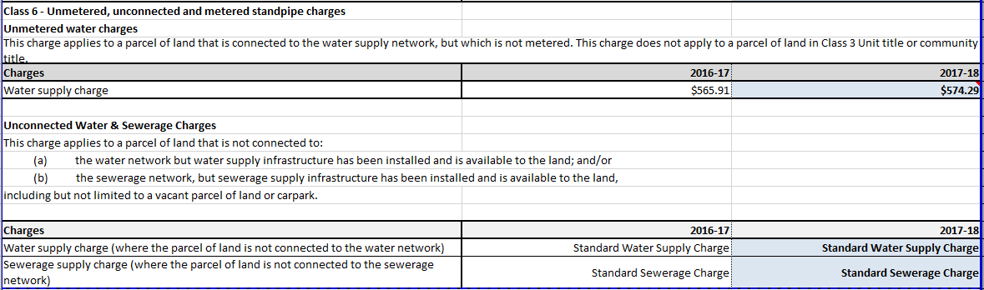



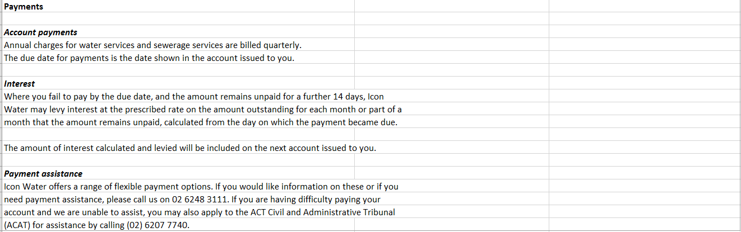







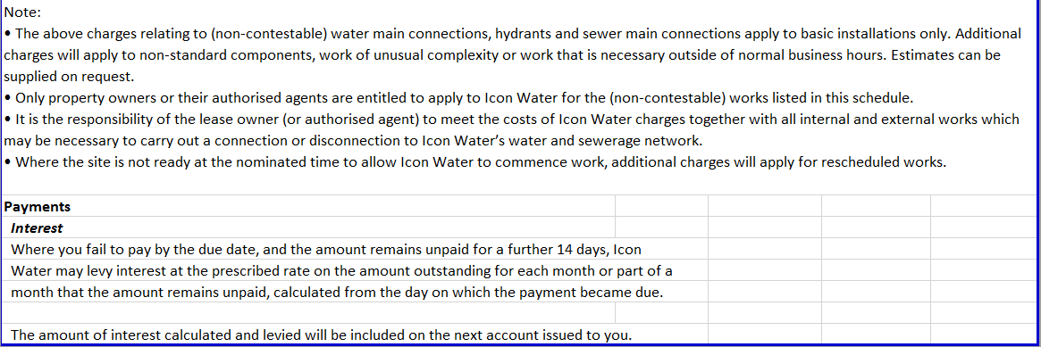

Abbreviations and acronyms

|  |  |
| --- | --- |
| Commission | Independent Competition and Regulatory Commission |
| CPI | Consumer price index |
| GST | Goods and services tax |
| ICRC | Independent Competition and Regulatory Commission |
| ICRC Act | Independent Competition and Regulatory Commission Act 1997 (ACT) |
| kL | kilolitre |
| price direction | *Substituted Price Direction for Regulated Water and Sewerage Services 1 July 2013 to 30 June 2018* |
| SCC | Standard customer contract |
| UNFT | Utilities Network Facilities Tax |
| WAC | Water abstraction charge |
|  |  |
|  |  |
|  |  |
|  |  |
|  |  |
|  |  |
|  |  |
|  |  |

References

Icon Water (2017) *Regulated water and sewerage services price adjustment for   
2017–18: Pass-through submission and new miscellaneous service charge application,* Icon Water, Canberra.

ICRC (2015) *Statement on Commission-initiated pass-through events*.Independent Competition and Regulatory Commission, Canberra. May 2015.

Industry Panel (2015a) *Substituted Price Direction: Regulated water and sewerage services 1 July 2013 to 30 June 2018 2013,* Industry Panel, Canberra. April 2015.

Industry Panel (2015b) *Review of the Independent Competition and Regulatory Commission’s 2013 Price Direction for regulated water and sewerage services in the ACT: Final report,* Industry Panel, Canberra. April 2015.

1. Industry Panel (2015a). Available at: http://www.icrc.act.gov.au/water-and-sewerage/inquiries-and-investigations/.
2. The details of the proposed changes to the schedule of charges can be found in Appendix 1 of this report.
3. The CPI adjustment for 2017−18 prices is not a forecast of inflation in that year but rather is based on historical changes in the CPI up to March 2017 from June 2015 based on quarterly figures, using the ‘four quarter on four quarter’ approach. The CPI data (weighted average of eight capital cities) are available from the Australian Bureau of Statistics website at http://www.abs.gov.au/ausstats/abs@.nsf/0/938DA570A34A8EDACA2568A900139350.
4. The methodology is described in Industry Panel 2015a and 2015b.
5. The 2017−18 price adjustments have been made after removing the 2014−15 negative pass-through amounts, which have been already passed-through to customers as part of 2016−17 price reset.
6. The calculations include the application of daily pricing consistent with historical water use in each quarter. This means that 200 kL per year customers pay for a small amount of water at the tier 2 price in some quarters.